Equivalent Fractions
If we multiply the numerator and denominator of a fraction with same number simultaneously, the fractions we get are similar, same or equal to the previous fraction. Such fractions are called similar or equal fractions.
Let us take a fraction 1/2 . If we multiply the numerator and denominator of the fraction by any number; we get following fractions:
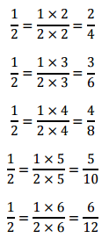
In this case all are similar fractions, i.e. all have same value.
